Given the root of an n-ary tree, return *the postorder traversal of its nodes' values*.

Nary-Tree input serialization is represented in their level order traversal. Each group of children is separated by the null value (See examples)

**Example 1:**

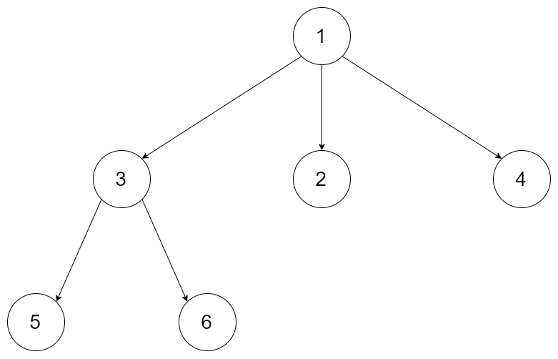

**Input:** root = [1,null,3,2,4,null,5,6]

**Output:** [5,6,3,2,4,1]

**Example 2:**

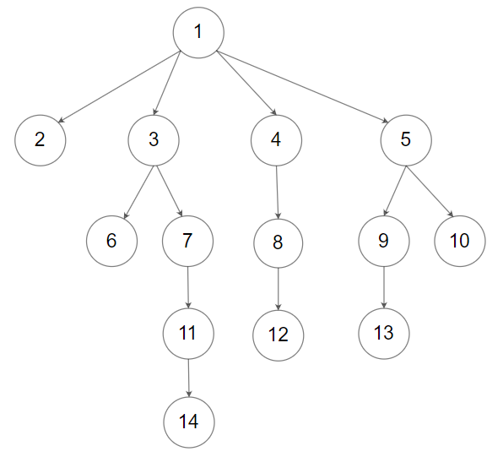

**Input:** root = [1,null,2,3,4,5,null,null,6,7,null,8,null,9,10,null,null,11,null,12,null,13,null,null,14]

**Output:** [2,6,14,11,7,3,12,8,4,13,9,10,5,1]

**Constraints:**

* The number of nodes in the tree is in the range [0, 104].
* 0 <= Node.val <= 104
* The height of the n-ary tree is less than or equal to 1000.

**Follow up:** Recursive solution is trivial, could you do it iteratively?